The next section of this paper is focused on explaining some of the advantages of electric cars and breaking down some misconceptions that people have about electric vehicles. This section will be split up into a few categories: environmental advantages, financial advantages, and finally safety advantages.
The first benefit of electric cars is their positive impact on the environment, which is ultimately the reason why electric cars are the car of the future. This impact can be broken down into multiple categories, starting with the emissions released by cars. The most obvious benefit is that electric cars have zero direct emissions, as opposed to their gasoline counterparts, which on average emit 4.6 metric tons of carbon dioxide per year. Those emissions together with the same emissions from other modes of transportation make up the largest individual portion of all the greenhouse gases that are polluting our planet.
There is a second type of emissions that also produces greenhouse gases which is called well to wheels emissions. These emissions refer to the gases that are being emitted and pollute the environment through the process of producing and distributing the energy used to power cars. These emissions do apply to electric vehicles as well as gasoline powered ones, and even were thought of as worse than the direct emissions that had been previously thought of as the only component of polluting our environment. Old studies had shown that in manufacturing electric vehicles there was between twenty and seventy percent more emissions than for the manufacture of gasoline powered vehicles. However, a report from the Vehicle Technologies Office of the US Department of Energy shows that while the previous studies were true, the media had been misrepresenting the full data. After analyzing all the data (Vehicles Technologies Office, 2015) concludes that, “The national average is 4,815 pounds of CO2-equivalent emissions for a typical EV per year as compared to the average gasoline-powered car which produces 11,435 pounds of CO2-equivalent emissions annually.” This report makes it simple to understand to anyone that even with the extra emissions from the manufacturing the electric vehicle is still significantly better for our environment.
Finally, even this study is not fully explaining the environmental advantages of electric vehicles. These numbers are not including the fact that above 90 percent of the materials in electric cars batteries are able to be recycled and used in the production of new batteries, which would drastically lower the CO2-equivalent emissions needed in production of the cars. Tesla’s impact report (2019) states:
At Gigafactory 1, Tesla is developing a unique battery recycling system that will process both battery manufacturing scrap and end-of-life batteries. Through this system, the recovery of critical minerals such as lithium and cobalt will be maximized along with the recovery of all metals used in the battery cell, such as copper, aluminum and steel. All of these materials will be recovered in forms optimized for new battery material production.
Speculation from this report was that in the future as more Tesla vehicles enter and exit the road there is a possibility that up to half of the production of new batteries will have come from old batteries.

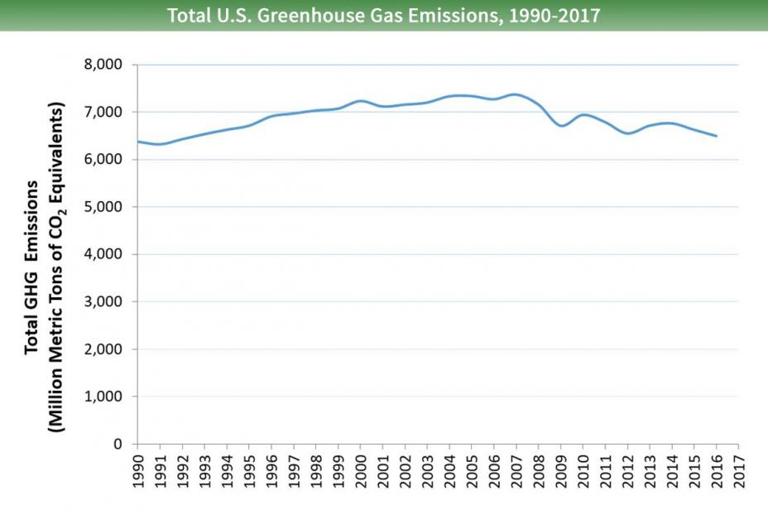
To conclude on the topic of Greenhouse gas emissions, I have included a graph that helps explain how the shift to electric vehicles has already begun to help our environment. As the total of cars has continued to increase year after year, the amount of emissions increased as well peaking at about 7.3 million metric tons of CO2 in 2007. In the ten years after that the number has decreased all the way to 6.5 million a double digit percent decrease due in large part to the increase of electric vehicles from under 1000 on the road in 2007 to close to one million by 2017. With this number increasing drastically annually, and the emissions in response decreasing, it seems that electric vehicles might be the answer to the “Global warming” problem that has been highly debated for the last number of years.
The next advantage is not as obvious, and in fact is a rebuttal to one of the most common disadvantages which is the financial impact. Although it is true that electric cars are definitely more expensive than their gasoline counterparts, this is only true on a very basic level. To use an example the 2019 Nissan Leaf starts at around 30 thousand dollars, which is 6 thousand more than its counterpart the Nissan Altima however, as will be explained the electric car is really the better financial option.
The first reason why the electric vehicles are in reality “cheaper” is because of the efficiency of these vehicles. For gasoline powered vehicles, only about twenty percent of the energy from the gasoline being burnt can be used to power the cars. Electric vehicles, on the other hand, can convert around sixty percent of the electricity being used in order to power the vehicle. Another way of looking at this is that for cars that are improving their average miles per gallon standards, twenty-five miles per gallon is considered the average level of efficiency. In contrast, electric vehicles are far superior in this regard, with their comparable “miles per gallon” approaching 100 miles per gallon.
Another aspect in which electric cars have an advantage over their gasoline powered counterparts is regarding the cost of owning and running the vehicles. For regular gasoline powered vehicles, there are many parts that generally go bad over time and must be replaced since there are dozens of components in their engines including spark plugs, air filters, head gaskets and many other parts. Electric vehicles, conversely, only have one moving part in their motor, so the multitude of replacement costs is not incurred. Additionally, the cost of powering the gasoline vehicles ranges, on average, from $2.50 to $3.00 per gallon, while the electric gallon is priced around $1.10 per gallon. Combining the huge difference in gas prices, along with massive differences regarding efficiency of the gas for the different vehicles, leads to a cost of about eight times as much to run a gasoline powered car.
Finally, one last financial benefit is the Federal tax rebate given to anyone who purchases an electric vehicle, which ranges between 2,500 and 7,500 dollars. Continuing with using the Nissan Leaf which receives a 7500 dollar rebate and Altima for comparison, if we assume that both cars drive 10,000 miles a year and last ten years it is clear that the Leaf ends up cheaper. Just viewing the price of the car and gas, the Altima wound end up costing someone over 35,000 dollars while the Leaf with the rebate would be well under 30,000 dollars.
The last advantage of electric cars over gasoline powered cars is with regard to their safety. One massive safety advantage is regarding vehicle fires. The second leading cause of fatal highway vehicle fires originates from the gas tank, the absence of which in electric vehicles removes this hazard. This is a big advantage when you consider the over 34,000 people annually that are killed when gasoline powered cars go up in smoke. Additionally, since most of the electric car’s power source can be placed underneath the car, designers have much more leeway in the way the car is designed. An example of a resulting design change is the larger “crumple zone” which is the part of the car that absorb the force of crashes and prevents the passengers from taking the impact. Not only does placing the battery under the car help with the car being able to absorb impact, it also allows the car to have a lower center of gravity. Having a lower center of gravity helps the car avoid flipping over when involved in a collision and makes the care more stable in general.

